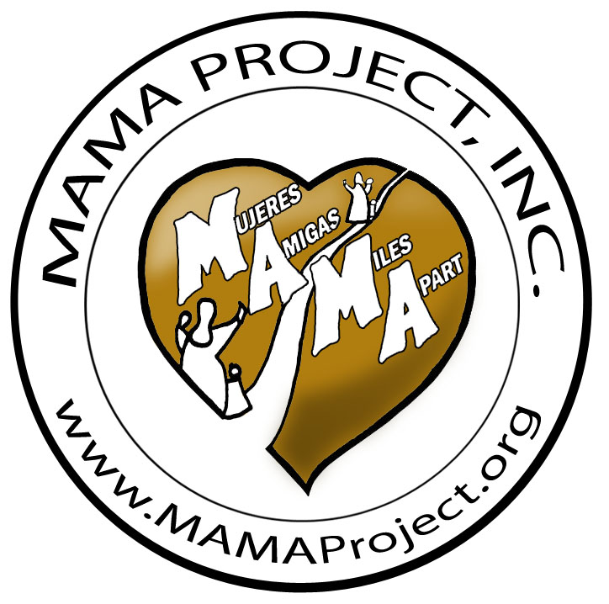

Crianza de Guineas y Pollos en la Comunidad
MAMA Project Policies
- Every community that wishes to participate in the guinea project must have a person or group designated to direct the project in that community

- That person or group will decide with the community where the first guinea flock will be located. Examples: School, private home, or church

- Before the community receives the young guineas from MAMA Project, they must have a shelter prepared to protect he birds from high winds, rain, cold, sun and predators. About 2-3 square feet per guinea when they are confined

- MAMA Project in San Francisco de Yojoa will supply young guineas that are at least 2 weeks old.

- MAMA Project will not charge for the guineas. MAMA Project will pay travel on public bus for two to three people to come from their community to San Francisco de Yojoa, provide a meal for everyone at the nutrition center, and if necessary, overnight accomodations at the Mission House.

- The guineas will be transported back in large boxes with good ventilation. Example: If the keets are picked up and transported on the bus at 2 weeks old, 20 keets can fit into a square 2 foot x 2 foot by 6 inch tall cardboard box with a lot of ventilation holes. If the young guineas are 6 weeks old, only 5 will fit into the same box, and the box height should be 12 inches tall

- The guineas should be confined inside in a galinera that is of adequate size until they are accustomed to their new surroundings, and has been trained to come home to roost. (See instruction sheets)

- The first 12-20 guineas will be the breeding stock. Initially, the eggs and guineas should not be eaten, but used for reproduction

- Before receiving their gunineas, the family must build a shelter and learn how to care for guineas,

- The family must be prepared to feed the guineas as they would chickens of the same age, until they are allowed to free range and eat insects

- Final goal is that everyone in the community will be able to have guineas

- Priority families will be the ones who have registered and indicated their desire to have guineas

- Registration is open during Evaluation and Monitoring visits

15Mayo2016 - PB

