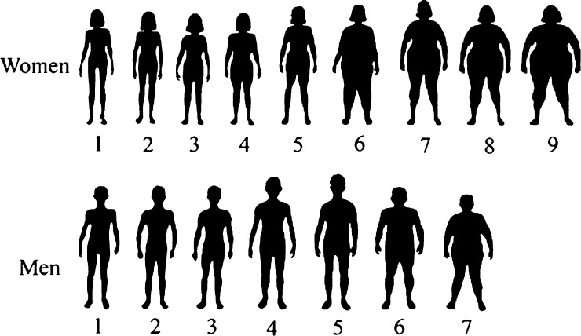
Praziquantel Dosage Pictogram for Adults

When dosing Praziquantel, use the modified pole with 11 demarcations, starting at 60 cm for infants and preschool children, through adults over 178 cm.
Overweight and obese adults, both men and women should receive an additional 600 mg tablet of Praziquantel if they have body shape labeled 6 or above by the pictogram; these are the body images in the boxes. The adjustment for overweight and obesity avoids under-dosing larger adults.
Ref:Am J Trop Med Hyg. 2014 Apr 2; 90(4): 634–637. Chart-MAMA Project 29March2019

