How to Filter and Chlorinate Water
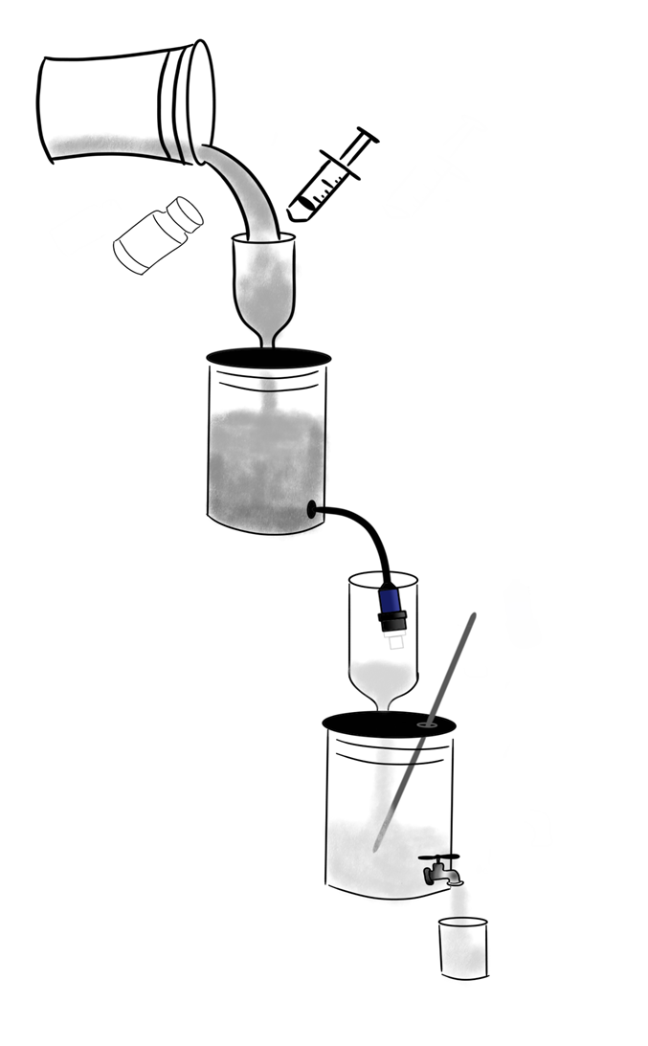  www.MAMAProject.org  info@MAMAProject.org | 1 | As you gather water, fill a spare 5-gallon container and let dirt in the water settle to the bottom for 1-24 hours. Keep the lid on the spare bucket.
 | 2 | Gently pour off the clear water into top bucket, discarding the dirty water or use to water plants or animals.
 | 3 | If Schistosomiasis is a problem in your community, let all water used in household, even for bathing, cooking or laundry rest 1-2 days.
 | 4 | When ready to start filtering the full top bucket, position filter within plastic bottle of the bottom bucket. Remove cap, and water will flow.
 | 5 | If flow slows down, or stops, that indicates a clogged filter. Follow directions to backwash with filtered water.
 | 6 | Once system is clean and operating, never put anything into bottom bucket. Keep lid on to protect water and children.
 | 7 | When bottom bucket is full of filtered water, recap filter and hang on edge of top bucket
 | 8 | Using 1cc syringe, measure 1cc calcium or sodium hypochlorite (5.25%) solution, or drinking water tablets (Nadcc) such as Aquatabs or Water Guard. See directions in Water Filtration and Chlorination Training Video
 | 9 | Through opening in bottom lid, add the chlorine solution, and stir 12 times. For tablets, stir 10 minutes. Never remove stir stick.
 | 10 | Wait 30 minutes before drinking to give chlorine time to work. To be sure, fill a small glass to do the “sniff test”. You want a very faint chlorine aroma
 | 11 | If no aroma of chlorine, perhaps solution is not fresh, or a lower concentration, so repeat, to usually 3- 5cc total. Tablets are more stable than liquids, and stay fresh longer. Be sure to use the correct number.
 | 12 | Store chlorine solution bottle and syringe or chlorine tablets, filter cap and backwasher in bottle attached to lid on top bucket- safely out of reach of children
 | 13 | Bottle attached to bottom lid protects filter. Opening should be plugged if not actively filtering water, to prevent contamination of pure water.

